**Name:** Muhammad Zeeshan Haider

**Class:** BSCS-4B (Evening)

**Roll Number: 22-ARID-858**

**Assignment # 02**

**Code:**

**Index.html:**

<!DOCTYPE html>

<html lang="en">

<head>

    <meta charset="UTF-8">

    <meta name="viewport" content="width=device-width, initial-scale=1.0">

    <title>School Website</title>

    <link rel="icon" href="logo.png">

    <link rel="stylesheet" href="style.css">

    <link href='https://unpkg.com/boxicons@2.1.4/css/boxicons.min.css' rel='stylesheet'>

</head>

<body>

    <section class="header">

        <nav>

            <a href="#"><img src="logo.png" ></a>

            <div class="nav-links" id="navLinks">

                <i class='bx bx-x' onclick="hideMenu() " id="hide"></i>

                <ul>

                    <li><a href="#">Home</a></li>

                    <li><a href="#">About</a></li>

                    <li><a href="#">Course</a></li>

                    <li><a href="#">Blog</a></li>

                    <li><a href="#">Contact</a></li>

                </ul>

            </div>

            <i class='bx bx-menu' onclick="showMenu()" id="show"></i>

        </nav>

        <div class="text-box">

            <h1>World's Biggest School System</h1>

            <p>Welcome to Eduford School System, where learning knows no bounds and excellence is our tradition.At Eduford School System, we believe in nurturing young minds, fostering creativity, and empowering students to become tomorrow's leaders. Our commitment to academic excellence, combined with a supportive community and state-of-the-art facilities, ensures that every student has the opportunity to thrive and succeed.Explore our comprehensive curriculum, led by passionate educators who are dedicated to inspiring a lifelong love of learning. From STEM programs to the arts, athletics to community service, we offer a diverse range of opportunities for students to discover their passions and reach their full potential.</p>

            <a href="#" class="hero-btn">Visit us to know more</a>

        </div>

        <div class="bubbles">

            <img src="bubble.png">

            <img src="bubble.png">

            <img src="bubble.png">

            <img src="bubble.png">

            <img src="bubble.png">

            <img src="bubble.png">

            <img src="bubble.png">

            <img src="bubble.png">

            <img src="bubble.png">

            <img src="bubble.png">

            <img src="bubble.png">

        </div>

    </section>

    <section class="course">

<h1>Courses We Offer</h1>

<p>

    Welcome to our Courses Page!

    At Eduford School System, we believe in providing our students with a diverse and enriching educational experience. Our courses are carefully curated to cater to a wide range of interests and academic pursuits. Whether you're passionate about the sciences, humanities, arts, or technology, you'll find a course that ignites your curiosity and fuels your desire to learn.Start your educational journey with us today!</p>

    <div class="row">

        <div class="course-col">

            <h3>Primary</h3>

            <p>Lorem ipsum dolor sit amet, consectetur adipisicing elit. Ad corrupti impedit dolor aspernatur vero, inventore expedita obcaecati temporibus repudiandae est. Lorem ipsum dolor sit amet consectetur, adipisicing elit. Necessitatibus, error. Lorem ipsum dolor sit amet consectetur adipisicing elit. Earum, sunt.</p>

        </div>

        <div class="course-col">

            <h3>Matric</h3>

            <p>Lorem ipsum dolor sit amet, consectetur adipisicing elit. Ad corrupti impedit dolor aspernatur vero, inventore expedita obcaecati temporibus repudiandae est. Lorem ipsum dolor sit amet consectetur, adipisicing elit. Necessitatibus, error. Lorem ipsum dolor sit amet consectetur adipisicing elit. Earum, sunt.</p>

        </div>

        <div class="course-col">

            <h3>Intermediate</h3>

            <p>Lorem ipsum dolor sit amet, consectetur adipisicing elit. Ad corrupti impedit dolor aspernatur vero, inventore expedita obcaecati temporibus repudiandae est. Lorem ipsum dolor sit amet consectetur, adipisicing elit. Necessitatibus, error. Lorem ipsum dolor sit amet consectetur adipisicing elit. Earum, sunt.</p>

        </div>

    </div>

    </section>

    <!-- Section Campus -->

    <section class="campus">

        <h3>Our Global Campus</h3>

        <p>Lorem ipsum dolor sit amet consectetur adipisicing elit. Beatae mollitia voluptate vero.</p>

        <div class="row">

            <div class="campus-col">

                <img src="london.png" alt="">

                <div class="layer">

                    <h3>London</h3>

                </div>

            </div>

            <div class="campus-col">

                <img src="washington.png" alt="">

                <div class="layer">

                    <h3>Washington</h3>

                </div>

            </div>

            <div class="campus-col">

                <img src="newyork.png" alt="">

                <div class="layer">

                    <h3>New York</h3>

                </div>

            </div>

        </div>

    </section>

    <!-- facilities -->

    <section class="facilities">

        <h1>Our Facilities</h1>

        <p>Lorem ipsum dolor, sit amet consectetur adipisicing elit. Corrupti, blanditiis! Omnis, non.</p>

        <div class="row">

            <div class="facilities-col">

                <img src="library.png">

                <h3>World Class Library</h3>

                <p>Lorem ipsum dolor sit amet, consectetur adipisicing elit. Fuga illum doloribus maxime nihil et quaerat voluptatem numquam assumenda animi in?</p>

            </div>

            <div class="facilities-col">

                <img src="basketball.png">

                <h3>Largest Play Ground</h3>

                <p>Lorem ipsum dolor sit amet, consectetur adipisicing elit. Fuga illum doloribus maxime nihil et quaerat voluptatem numquam assumenda animi in?</p>

            </div>

            <div class="facilities-col">

                <img src="cafeteria.png">

                <h3>Tasty and Healthy Food</h3>

                <p>Lorem ipsum dolor sit amet, consectetur adipisicing elit. Fuga illum doloribus maxime nihil et quaerat voluptatem numquam assumenda animi in?</p>

            </div>

        </div>

    </section>

    <!-- testimonials -->

    <section class="testimonials">

        <h1>What our students says?</h1>

        <p>Lorem ipsum dolor, sit amet consectetur adipisicing elit. Corrupti, blanditiis! Omnis, non.</p>

        <div class="row">

            <div class="testimonials-col">

                <img src="user1.jpg" alt="">

                <div>

                    <p>Lorem ipsum, dolor sit amet consectetur adipisicing elit. Architecto inventore consequuntur repudiandae maxime </p>

                    <h3>Christine Berry</h3>

                    <i class='bx bxs-star'   ></i>

                    <i class='bx bxs-star'   ></i>

                    <i class='bx bxs-star'   ></i>

                    <i class='bx bxs-star'   ></i>

                    <i class='bx bxs-star-half'   ></i>

                </div>

            </div>

            <div class="testimonials-col">

                <img src="user2.jpg" alt="">

                <div>

                    <p>Lorem ipsum, dolor sit amet consectetur adipisicing elit. Architecto inventore consequuntur repudiandae maxime </p>

                    <h3>David Byer</h3>

                    <i class='bx bxs-star'   ></i>

                    <i class='bx bxs-star'   ></i>

                    <i class='bx bxs-star'   ></i>

                    <i class='bx bxs-star'   ></i>

                    <i class='bx bx-star'  ></i>

                </div>

            </div>

        </div>

    </section>

    <!-- call to action section  -->

    <section class="cta">

        <h1>Enroll for our various online courses <br> anywhere from the World</h1>

        <a href="" class="hero-btn">CONTACT US</a>

    </section>

    <!-- footer  -->

    <section class="footer">

        <h4>About us</h4>

        <p>Lorem ipsum, dolor sit amet consectetur adipisicing elit. Vero eaque expedita natus  iste ea veniam harum <br> Lorem ipsum dolor sit amet consectetur adipisicing elit. Dolorum, laudantium.</p>

        <div class="icons">

            <i class='bx bxl-facebook'></i>

            <i class='bx bxl-instagram'></i>

            <i class='bx bxl-linkedin'></i>

            <i class='bx bxl-twitter'></i>

            <p>Made with <i class='bx bxs-heart'></i> by Zeeshan Haider</p>

        </div>

    </section>

    <script src="index.js"></script>

</body>

</html>

**Style.css:**

*{

    margin: 0;

    padding: 0;

    box-sizing: border-box;

    font-family: 'Times New Roman', Times, serif;

}

.header{

    min-height: 100vh;

    position: relative;

    background-image: linear-gradient(rgba(4,9,30,0.7),rgba(4,9,30,0.7)),url('banner.png');

    background-position: center;

    background-size: cover;

}

nav{

    display: flex;

    justify-content: space-between;

    padding: 2% 6%;

    align-items: center;

}

nav img{

    width: 150px;

}

.nav-links{

flex: 1;

text-align: right;

}

.nav-links ul li{

    list-style: none;

    display: inline-block;

    padding: 8px 12px;

    position: relative;

}

.nav-links ul li a{

    text-decoration: none;

    color: white;

    font-size: 20px;

}

.nav-links ul li::after{

    content: '';

    width: 0%;

    background: #f44336;

    height: 2px;

    display: block;

    margin: auto;

    transition: 0.5s;

}

.nav-links ul li:hover::after{

width: 100%;

}

.text-box{

    width: 90%;

    position: absolute;

    top: 50%;

    left: 50%;

    text-align: center;

    transform: translate(-50%,-50%);

    color: white;

}

.text-box h1{

    font-size: 62px;

}

.text-box p{

    margin: 10px 0 40px;

    font-size: 14px;

}

.hero-btn {

    display: inline-block;

    background: transparent;

    padding: 8px 12px;

    text-decoration: none;

    color: #fff;

    font-size: 13px;

    border:1px solid #fff;

    position: relative;

    cursor: pointer;

}

.hero-btn:hover{

    background: #f44336;

    border: 1px solid #f44336;

    transition: 1s;

}

nav .bx{

    display: none;

}

@media(max-width:700px){

    .text-box h1{

        font-size: 20px;

    }

    .nav-links ul li{

        display: block;

    }

    .nav-links{

        position: absolute;

*/* padding-top: 150px; */*

        width: 200px;

        height: 100vh;

        z-index: 2;

        top: 0;

        right: -200px;

        text-align: center;

        background: rgba(0, 0, 0, 0.4);

        transition: 1s;

    }

    nav .bx{

        display: block;

        color: #fff;

        font-size: 30px;

        margin: 10px;

        cursor: pointer;

    }

}

.bubbles img{

    width: 50px;

    animation: bubble 7s linear infinite;

}

.bubbles{

    width: 100%;

    display: flex;

    justify-content: space-around;

    align-items: center;

    position: absolute;

    bottom: -70px;

}

@keyframes *bubble*{

    0%{

        transform: translateY(0);

        opacity: 0;

    }

    50%{

        opacity: 1;

    }

    70%{

        opacity: 1;

    }

    100%{

        transform: translateY(-80vh);

        opacity: 0;

    }

}

.bubbles img:nth-child(1){

    animation-delay: 2s;

    width: 25px;

}

.bubbles img:nth-child(2){

    animation-delay: 2.5s;

}

.bubbles img:nth-child(3){

    animation-delay: 10s;

    width: 25px;

}

.bubbles img:nth-child(4){

    animation-delay: 4.5s;

}

.bubbles img:nth-child(5){

    width: 25px;

    animation-delay: 3s;

}

.bubbles img:nth-child(6){

    animation-delay: 6s;

    width: 20px;

}

.bubbles img:nth-child(7){

    animation-delay: 7s;

    width: 35px;

}

.bubbles img:nth-child(8){

    animation-delay: 8s;

    width: 35px;

}

.bubbles img:nth-child(9){

    animation-delay: 8.1s;

    width: 35px;

}

.bubbles img:nth-child(10){

    animation-delay: 9s;

    width: 35px;

}

.bubbles img:nth-child(11){

    animation-delay: 10s;

    width: 35px;

}

@media screen and (max-width:600px){

    h1{

        font-size: 36px;

        line-height: 50px;

    }

    .sideBar{

        width:100%;

        height: 50px;

        top: auto;

        display: flex;

        justify-content: center;

        align-items: center;

        padding: 0 10px;

        box-sizing: border-box;

        bottom: 0;

    }

    .social-links{

        position: unset;

        width: auto;

        transform: none;

    }

    .useful-links{

        position: unset;

        bottom: 30px;

    }

    .menu{

        width: 18px;

        margin: 0;

    }

}

*/* courses section */*

.course{

    width: 80%;

    margin: auto;

    padding-top: 100px;

    text-align: center;

}

.course h1{

    font-size: 36px;

    font-weight: 600;

}

p{

padding: 10px;

line-height: 22px;

font-weight: 200;

font-size: 14px;

}

.row{

    display: flex;

    margin-top: 5%;

    justify-content: space-between;

}

.course-col{

    flex-basis: 31%;

    background: #fff3f6;

    border-radius: 10px;

    margin-bottom: 5%;

    padding: 20px 12px;

    transition: 0.5s;

}

h3{

    text-align: center;

    font-weight: 600;

    margin: 10px 0;

}

.course-col:hover{

    box-shadow: 0 0 20px 0px rgba(0, 0, 0, 0.2);

}

@media(max-width:700px){

    .row{

        flex-direction: column;

    }

}

*/* ----Campus */*

.campus{

    width: 80%;

    margin: auto;

    text-align: center;

    padding-top: 50px;

}

.campus-col{

    flex-basis: 32%;

    position: relative;

    margin-bottom: 30px;

    overflow: hidden;

}

.campus-col img{

    width: 100%;

    display: block;

}

.layer{

    background: transparent;

    height: 100%;

    width: 100%;

    position: absolute;

    top: 0;

    left: 0;

    transition: 0.5s ease-in-out;

}

.layer:hover{

    background: rgba(226, 0, 0, 0.7);

}

.layer h3{

    width: 100%;

    font-weight: 900;

    color: #fff;

    bottom: 0;

    left: 50%;

    position: absolute;

    transform: translateX(-50%);

    opacity: 0;

    transition: 0.5s;

}

.layer:hover h3{

    bottom: 49%;

    opacity: 1;

}

*/* facilities section  */*

.facilities{

    width: 80%;

    margin: auto;

    text-align: center;

    padding-top: 50px;

}

.facilities-col{

    flex-basis: 31%;

    border-radius: 10px;

    text-align: left;

    margin-bottom: 5%;

}

.facilities-col img{

    width: 100%;

    display: block;

}

.facilities-col p{

    padding: 0;

}

.facilities-col h3{

    margin-top: 16px;

    margin-bottom: 15px;

    text-align: left;

}

*/* testimonials */*

.testimonials{

    width: 80%;

    margin: auto;

    text-align: center;

    padding-top: 100px;

}

.testimonials-col{

    flex-basis: 44%;

    border-radius: 10px;

    margin-top: 5%;

    text-align: left;

    background: #fff3f6;

    padding: 25px;

    cursor: pointer;

    display: flex;

}

.testimonials-col img{

    height: 100px;

    margin-left: 5px;

    margin-right: 30px;

    border-radius: 50%;

}

.testimonials-col p{

    padding: 0;

}

.testimonials-col h3{

    margin-top: 15px;

    text-align: left;

}

.testimonials-col .bx{

    color: #f44336;

}

@media(max-width:700px){

    .testimonials-col img{

        margin-left: 0px;

        margin-right: 15px;

    }

}

*/* call to action section */*

.cta{

    margin: 100px auto;

    width: 80%;

    background-image: linear-gradient(rgba(0,0,0,0.7),rgba(0,0,0,0.7)),url('banner2.jpg');

    background-position: center;

    background-size: cover;

    border-radius: 10px;

    text-align: center;

    padding: 100px 0;

}

.cta h1{

    color: #fff;

    margin-bottom: 40px;

}

@media(max-width:700px){

    .cta h1{

        font-size: 24px;

    }

}

*/* footer */*

.footer{

    width: 100%;

    text-align: center;

    padding: 30px 0;

}

.footer h4{

    margin-bottom: 25px;

    margin-top: 20px;

    font-weight: 600;

}

.icons .bx{

    color: #f44336;

    margin: 0 13px;

    cursor: pointer;

    padding: 18px 0;

}

**Index.js:**

var navLinks = document.getElementById("navLinks");

var show = document.getElementById("show");

var hide = document.getElementById('hide');

function hideMenu(){

    navLinks.style.right = "-200px";

    show.style.display = "block";

}

function showMenu(){

    navLinks.style.right = "0";

    show.style.display = "none";

    hide.style.display = "block";

}

**Designs:**

**Page 01:**



**Page 02:**

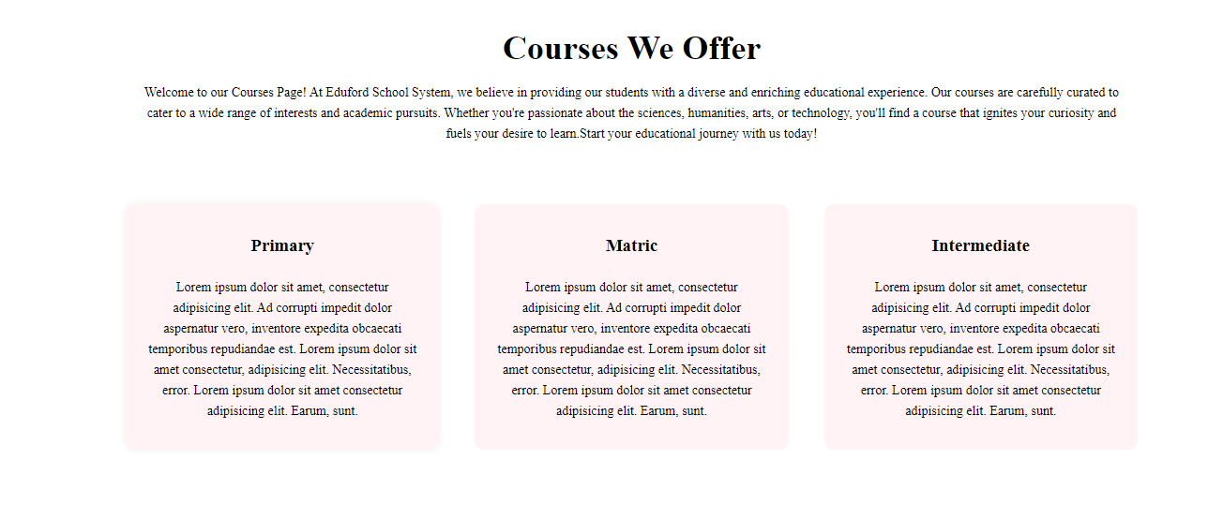

**Page 03:**

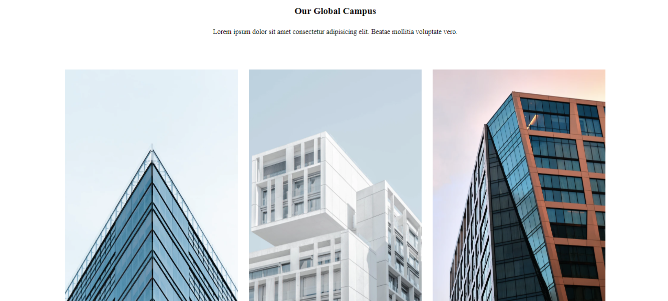

**Page 04:**

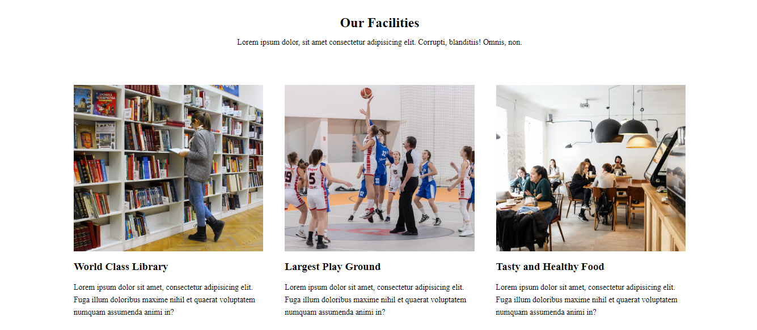

**Page 05:**

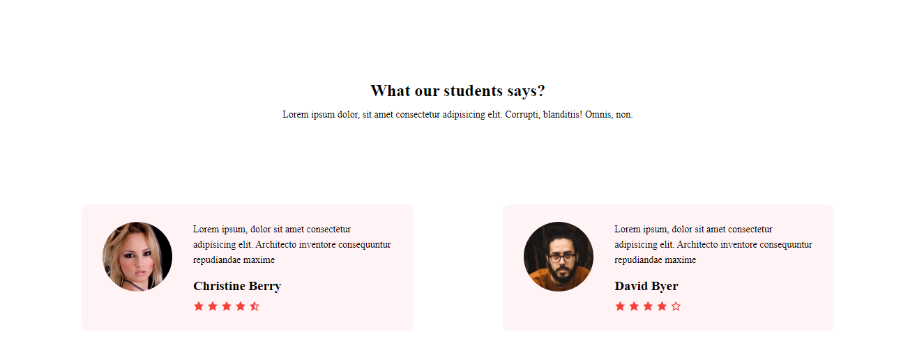

**Page 06:**



**Page 07:**

